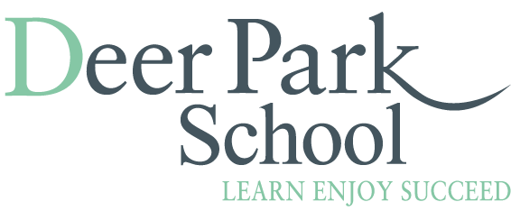

Home School Agreement and Extended Day Agreement Declaration

As per the Home School Agreement I/We will:
- Support the Deer Park School vision and the core values it promotes through H.E.A.R.T.
- Make sure my/our child comes to school on time and ready to learn
- Make sure that my/our child is wearing the correct school uniform
- Notify the school if my/our child is going to be absent for any reason
- Let the school know about any concerns or problems that might affect my/our child’s work or behaviour
- Take an active interest in my child’s life at school and attend meetings about my child’s progress
As per the Extended Day Agreement, we will:
- Make a commitment to book for a whole term
- Ensure that I communicate with staff regarding who is picking up my child
- Make payments on time via SchoolBuddy
- Collect my child/children on time
- Ensure that staff know of any allergies/medical
- Requirements for my child/children
I/We understand,
- That I may lose my child’s place and incur a fine if we are late to collect more than three times in a term.
- That I may lose my child’s place if he/she continuously
- behaves in a manner that contradicts the expectations set out in the school’s behaviour policy

I have read and understand the Home School Agreement and Extended Day Agreement.
Signed______________________________________________________

Child’s name and class:_______________________________________________________

